


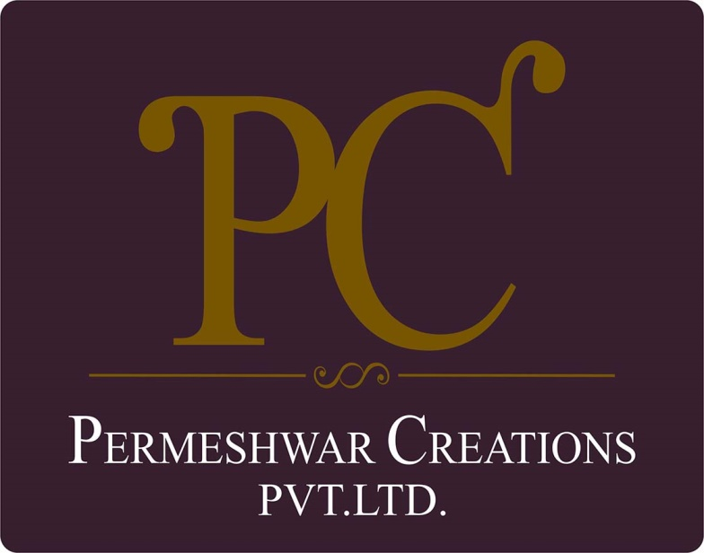

POLICY ON

RESPONSIBLE SOURCING
With effective from: 01/04/2023
Revision: 01
Last review date: 01/01/2024
Next review date: 01/01/2025

TABLE OF CONTENTS

Introduction 3
Scope 3
Policy Statement 3
Our Vision 3
SDGs Covered 4
Responsibility 4
Review Mechanism 4
Acknowledgement 5

Introduction
Permeshwar Creations is a renowned apparel manufacturing company in India, known for its commitment to quality, innovation, and sustainability. At Permeshwar Creations, we pride ourselves on being a leader in the apparel manufacturing industry. Since our inception, we have been dedicated to producing high-quality garments that meet the needs of our diverse clientele. Our research and development team continuously innovate, creating lightweight, fine-textured garments in a variety of beautiful colors and designs.

Scope
This policy covers all aspects of Permeshwar Creation’s operations, including manufacturing, transportation, and product lifecycle management. It applies to all workers, employees, suppliers, and stakeholders involved in our operations. This policy applies to below mentioned locations:

Address | PK Enterprises | C-19, Hoisery Complex, Phase II, Noida, U.P- 201301.India
Address | Rishita Fashion | Plot no. 1102, Phase III, GIDC,  Vapi, Valsad, Gujrat- 396195

Policy Statement
Permeshwar Creations recognizes the importance of sustainable procurement practices in mitigating environmental impact and promoting social responsibility. We aim to integrate environmental and labor/human rights issues into our supply chain management, alongside traditional procurement considerations of price, quality, and reliability.

Our Vision
Below are our commitments and targets towards ethical sustainability as compared to baseline year 2022.
- Supplier Environmental Practices
- Commitment to sourcing materials and products from suppliers with strong environmental management systems.
- By 2025, achieve a 20% reduction in the environmental footprint of sourced materials and products compared to 2022 baseline levels.
- Supplier Social Practices
- Commitment to working with suppliers that uphold fair labor practices, including safe working conditions and equitable wages.
- Ensure 100% of suppliers comply with international labor standards by 2025, up from 80% in 2022.
- Product Sustainability
- Encourage suppliers to provide products that are designed for durability, recyclability, and reduced environmental impact throughout their lifecycle.
- Increase the percentage of products meeting sustainable design criteria to 50% by 2025, from 30% in 2022.
- Local Sourcing and Community Impact
- Promote local sourcing to support regional economies and reduce transportation-related emissions.
- Increase local sourcing from 30% to 50% of total procurement by 2022.
- Supplier Diversity and Inclusion
- Foster partnerships with diverse suppliers, including minority-owned, women-owned, and small businesses.
- Increase procurement spend with diverse suppliers to 25% by 2025, from 15% in 2022.

SDGs Covered
This policy aligns with the United Nations Sustainable Development Goals (SDGs), particularly:

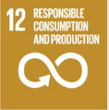
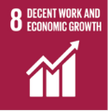

Responsibility
The responsibility for implementing and upholding this policy lies with every employee, director, officer, contractor, and agent of Permeshwar Creations. Senior management, led by the Human Resource Manager (HR), will oversee policy execution and provide necessary resources for successful implementation.

Review Mechanism
This policy will undergo annual reviews overseen by the Health, Right and Safety Manager, with the next review scheduled for 1st January 2025. Updates or amendments will be communicated to all stakeholders accordingly. Regular audits and reporting will ensure ongoing compliance with the policy's objectives and principles.

Acknowledgement
I Gladys Coutinho, acknowledge that I have read and understood this, Policy. I commit to upholding the principles outlined therein, including preventing corruption, ensuring responsible information management, promoting environmental sustainability, upholding supplier ethics, fostering a safe and inclusive workplace, and contributing positively to the Sustainable Development Goals (SDGs). I understand that compliance with this policy is a fundamental expectation and a condition of my employment with Permeshwar Creations.

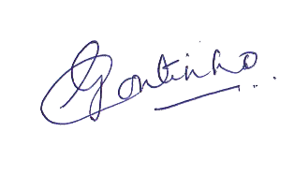
Employee Name: Gladys Coutinho

Employee Signature:

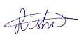

Approved by: Rishidev Gyandev Sadh
Designation: General Manager of Operations
Date: 07.01.2024

